Answers
Task 1
1. Look at the storage devices in the table below. For each one, tick whether it is magnetic, optical or solid state.
Storage device | Magnetic | Optical | Solid state
Hard disk drive
Blu-ray
CD ROM
USB flash drive
DVD RAM
SSD hard drive
SD card
Floppy disk drive
Backup tape drive
2. There are three different methods that are used to store data.
Name the three different methods.
Magnetic, optical, solid state

Task 2
Magnetic hard disks use a solid disk to store data.
(a) Complete the table below to explain the different parts of a magnetic hard disk.
Hard disk part | Explanation
Drive head | The head sits over one of the many tracks. It reads data as the disk rotates beneath it.
Actuator | Moves the head to different tracks on the disk.
Drive spindle | The spindle rotates the disk platter(s).
Platter | The disk is called a platter. Hard disks may have more than one platter to store more data. Some disks have data on just one side of the platter, others make use of both sides with the drive head reading both the top and bottom sides.
Track | A platter is split into concentric circles known as tracks.
Sector | The platter is divided into sectors which find data within a track.
(b) Describe the process involved in reading data from a hard disk.
The actuator will move the drive head so that it is over the correct track.
The drive head waits until the disk has spun to the correct sector that contains the data.
The data is read.
Some files are split over more than one location (this is known as fragmentation) – when this occurs, the drive head will need to move to all the tracks required (as above) one by one.

Task 3
Music used to be commonly sorted on vinyl records before CDs. Both are still in use today.
Research both vinyl records and CDs. Make notes of the similarities and differences between the two in the table below. The first similarity between the two has been given as an example.
 | Vinyl records | CDs
Similarities | - Makes use of a 12” disk.  - Stores around an hour of music in stereo  - Make use of one continuous groove (not concentric circles) | - Makes use of a 12 cm disk.  - Stores around an hour (of uncompressed) music in stereo  - Has one continuous path of data for the laser to follow
Differences | - Analogue recording  - Needle physical touches the disk to read it  - Spins at 45 or 75 rpm – this is a constant angular speed (the time it takes for one revolution) | - Digital recording  - Laser reflects off the disk; nothing physically touches it  - Spins at around 200-500 rpm with a constant linear speed (the number of bits that pass past the laser per second)

Task 4
The following shows a diagram of one memory cell inside a flash memory unit.
(a) Label the diagram to show:
- The isolation layers
- The floating gate
- The control gate
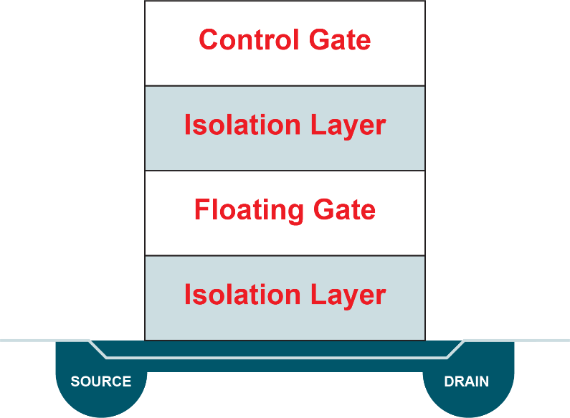
(b) How is it possible for such a flash memory unit to store data?
Electrons can be stored in the floating gate. They cannot escape through the isolation layer, but they are able to prevent electrical current going from the source to the drain.
If electrons are in the floating gate, it is storing a 0. If electrons are not in the floating gate, it stores a 1.

